# Openflow and Clos

1. OpenFlow v1.0 defines a format for flow table entries, shown in figure 2.
   1. Describe how these entries are used to direct traffic in a network with the help of an example.
   2. Discuss the limitations that this format may pose and suggest how these limitations may be addressed.

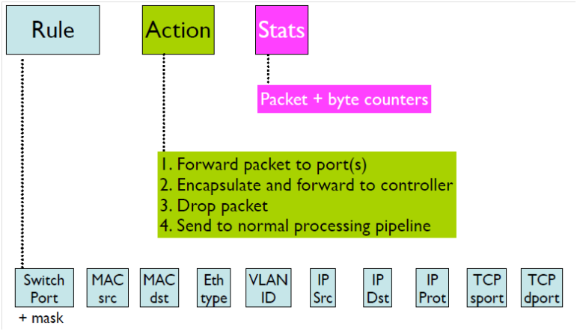

Figure : OpenFlow Flow Table Entry

1. Search for the types of OpenFlow messages and describe the exchange of messages between the controller and the routers in assignment 2 if they would be using OpenFlow.
2. Discuss the architecture for Software-Defined Networking (SDN) and how OpenFlow and Nypervisiors fit into this architecture to enable Software-Defined Networking.
3. Explain the advantages and disadvantages of a data centre where the hardware of the data centre may consist of 512 racks using a fat-tree topology in comparison to a traditional 4-post router approach.

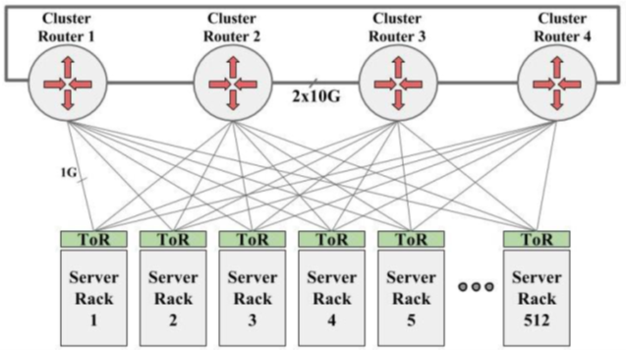

Figure : Data centre scenario with 512 racks and 4 routers*

1. Discuss the main difference between the traditional solution used by Google in their infrastructure in 2004 against the solution used in their Jupiter infrastructure.
2. Given the structure for a cluster in Google’s Jupiter Architecture, discuss where you could introduce OpenFlow and what results the use of OpenFlow you would expect.



= 40 servers

Flow Table

MAC

src

MAC

dst

IP

Src

IP

Dst

TCP

sport

TCP

dport

Action

OpenFlow Client

*

*

5.6.7.8

*

*

*

port 1



Controller

Figure : Cluster Architecture